Quacho basic board reparations

Due to the need to establish communication through serial protocol (Serial Peripheral Interface SPI) between the micro controller and a RF transceiver located in the rf shield PCB.

The ATSAM3S2 micro controller counts with one module spi and two usart modules that could be used to establish the communication named above.

At the point of choosing the module to use was found that some of the pins needed were not routed on Quacho Basic. The less difficult way to proceed would be choosing the usart1 module as spi. USART1 module on the mcu is fully routed, with the exception of the clock line (sck1) in the 22nd pin. As shown in the picture below, this line is unrouted.

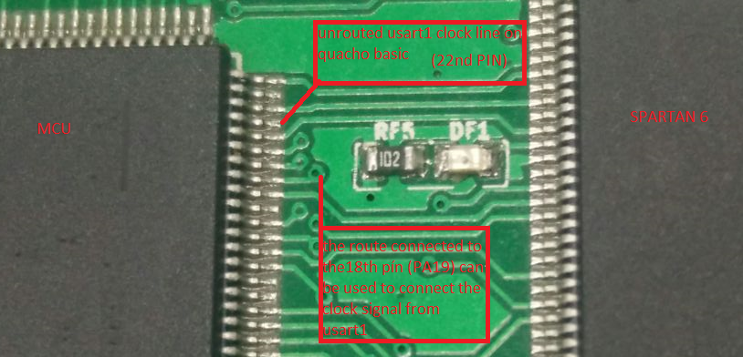

The proposed solution is to disconnect the mcu´s 18th pin from its route and use this to connect the clock signal witn the rf transceiver